1.

Create a class named 'Student' with String variable 'name' and integer variable 'roll_no'. Assign the value of roll_no as '2' and that of name as "John" by creating an object of the class Student.

class Student{

    //initialise variable

    String name;

    int roll_no;

    //constrctor

    Student(String name, int roll_no){

        this.name = name;

        this.roll_no = roll_no;

    }

    void display(){

        System.out.println("student name is " +name+ " and roll no is " +roll_no);

    }

}

class Demo1{

    public static void main(String[] args){

        Student s1 = new Student("John", 2);

        s1.display();

    }

}



2.

Assign and print the roll number, phone number and address of two students having names "Sam" and "John" respectively by creating two objects of class 'Student'.

class Student{

    //decalare variable

    String name;

    int roll_no;

    long phone_no;

    String add;

    //constructor

    Student(String name, int roll_no, long phone_no, String add){

        this.name = name;

        this.roll_no = roll_no;

        this.phone_no = phone_no;

        this.add = add;

    }

    void display(){

        System.out.println("name od student is " +name+

        " studenr roll no is " +roll_no+ " phone no is "

        +phone_no+ " address is "+add);

    }

}

class Demo2{

    public static void main(String[] args){

        Student s1 = new Student("Sam", 1, 832977, "nashik");

        Student s2 = new Student("John", 2, 814942, "mumbai");

        s1.display();

        s2.display();

    }

}

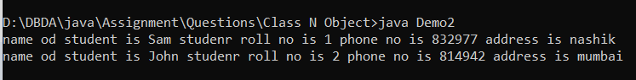

3.

Write a program to print the area and perimeter of a triangle having sides of 3, 4 and 5 units by creating a class named 'Triangle' without any parameter in its constructor.

class Triangle{

    //declare a varible

    int a=3;

    int b=4;

    int c=5;

    void Triangle(){

        double s = (a+b+c)/2.0;

        double area = Math.sqrt(s*(s-a)*(s-b)*(s-c));

        System.out.println("area of a triangle is: "+area);

        int t = 0;

        int p = a+b+c;

        System.out.println("perimeter of triangle is: " +p);

    }

}

class Demo3{

    public static void main(String[] args){

        Triangle t = new Triangle();

        t.Triangle();

    }

}

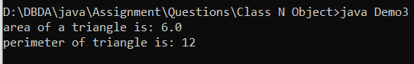

4.

Write a program to print the area and perimeter of a triangle having sides of 3, 4 and 5 units by creating a class named 'Triangle' with constructor having the three sides as its parameters.

class Triangle{

    //declare a varible

    int a,b,c;

    //constructor

    Triangle(int a, int b, int c){

        this.a = a;

        this.b = b;

        this.c = c;

    }

    void Triangle(){

        double s = (a+b+c)/2.0;

        double area = Math.sqrt(s*(s-a)*(s-b)*(s-c));

        System.out.println("area of a triangle is: "+area);

        int t = 0;

        int p = a+b+c;

        System.out.println("perimeter of triangle is: " +p);

    }

}

class Demo4{

    public static void main(String[] args){

        Triangle t = new Triangle(3,4,5);

        t.Triangle();

    }

}

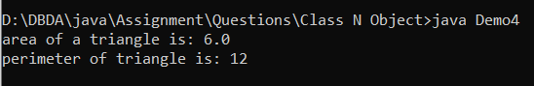

5.

Write a program to print the area of two rectangles having sides (4,5) and (5,8) respectively by creating a class named 'Rectangle' with a method named 'Area' which returns the area and length and breadth passed as parameters to its constructor.

6.

Write a program to print the area of a rectangle by creating a class named 'Area' having two methods. First method named as 'setDim' takes length and breadth of rectangle as parameters and the second method named as 'getArea' returns the area of the rectangle. Length and breadth of rectangle are entered through keyboard.

class Area{

    private int length,breadth,area;

    public void setDim(int length,int breadth){

        this.length=length;

        this.breadth=breadth;

        this.area=this.length*this.breadth;

    }

    public int getArea(){

        return this.area;

    }

}

class Demo5{

    public static void main(String[] args){

        Area a1=new Area();

        a1.setDim(4,5);

        System.out.println(a1.getArea());

    }

}



7.

Write a program to print the area of a rectangle by creating a class named 'Area' taking the values of its length and breadth as parameters of its constructor and having a method named 'returnArea' which returns the area of the rectangle. Length and breadth of rectangle are entered through keyboard.

8.

Print the average of three numbers entered by user by creating a class named 'Average' having a method to calculate and print the average.

9.

Print the sum, difference and product of two complex numbers by creating a class named 'Complex' with separate methods for each operation whose real and imaginary parts are entered by user.

10.

Write a program that would print the information (name, year of joining, salary, address) of three employees by creating a class named 'Employee'. The output should be as follows:

Name Year of joining Address

Robert 1994 64C- WallsStreat

Sam 2000 68D- WallsStreat

John 1999 26B- WallsStreat

class Employee{

    String name;

    int yr_of_joining;

    String address;

    Employee(String name,int yr_of_joining,String address){

        this.name=name;

        this.yr_of_joining=yr_of_joining;

        this.address=address;

    }

    void print(){

        System.out.println(this.name+"  "+this.yr_of_joining+"  "+this.address);

    }

}

class Demo9{

    public static void main(String[] args){

        Employee e1=new Employee("Robert",1994,"64C-WallsStreatR");

        e1.print();

        Employee e2=new Employee("Sam",2000,"68D- WallsStreat");

        e2.print();

        Employee e3=new Employee("John",1999,"26B- WallsStreat");

        e3.print();

    }

}

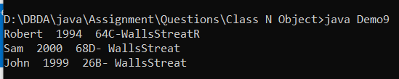

11.

Add two distances in inch-feet by creating a class named 'AddDistance'.